**Name:**

**Date:**

1. 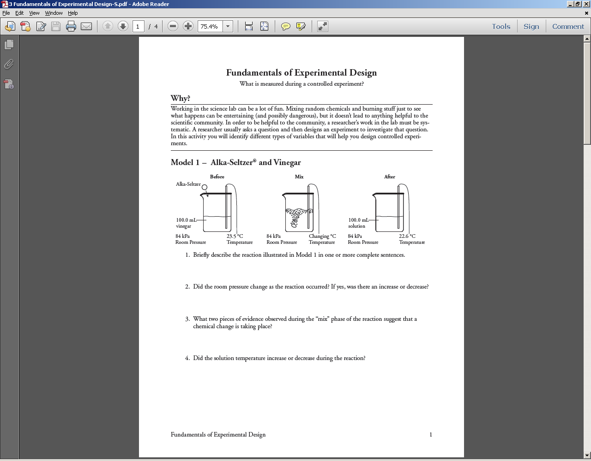**Learning Target: Identify the three types of variables in an experiment.**

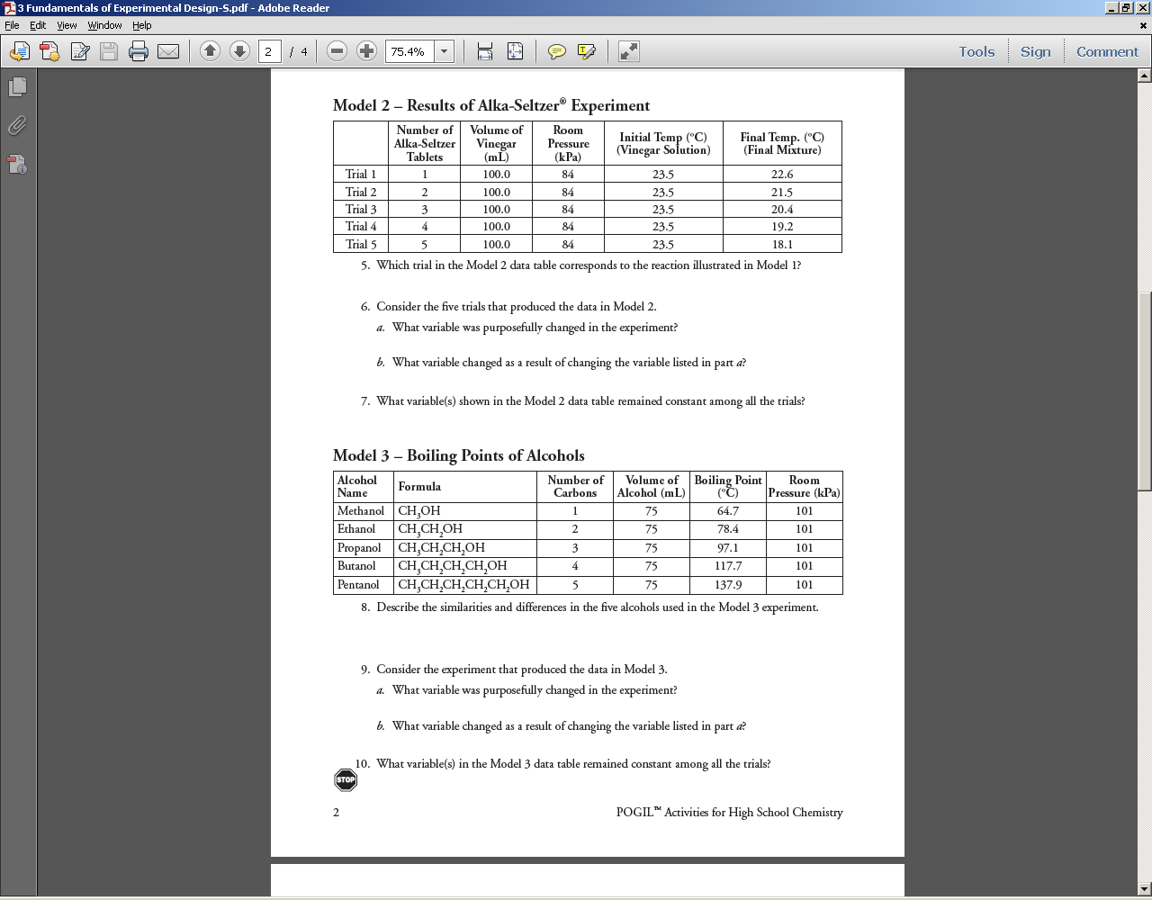

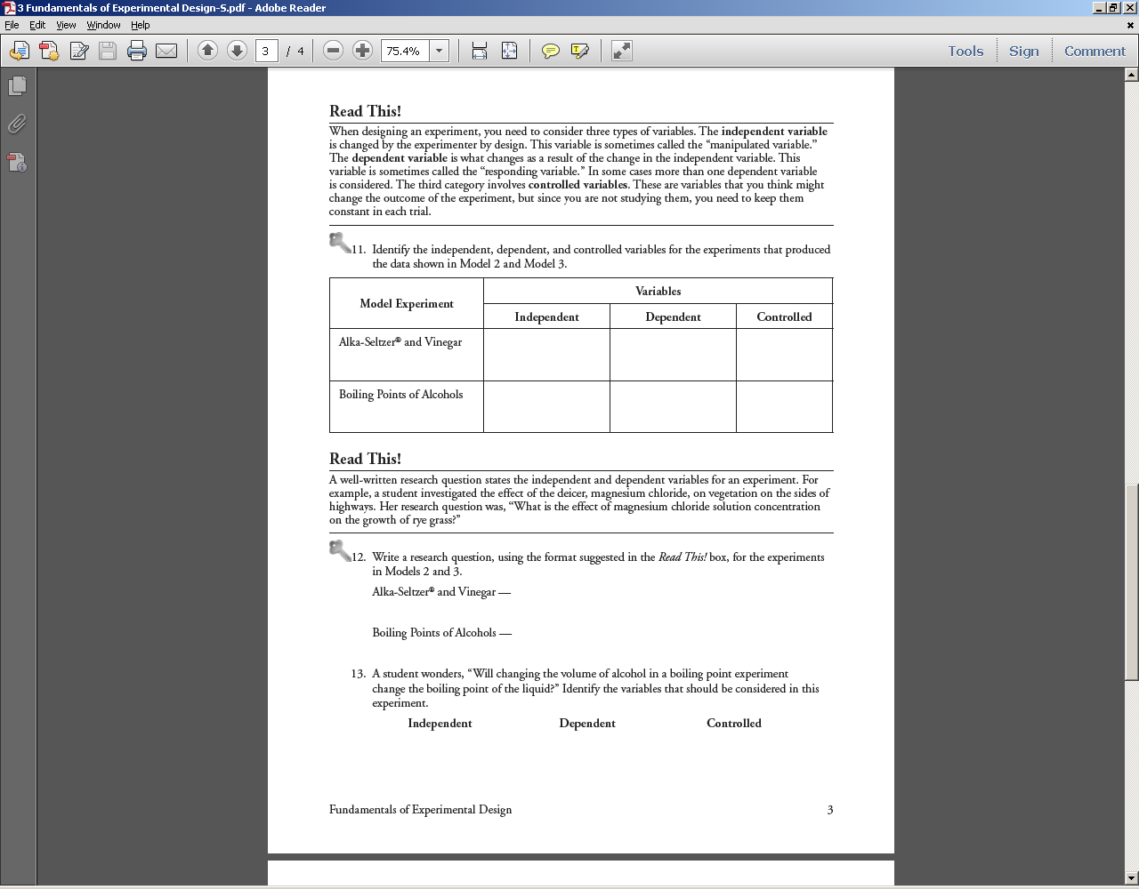

C:\Documents and Settings\MWiedenfeld\Local Settings\Temporary Internet Files\Content.IE5\34HD219W\MC900411244[1].wmf Call your instructor over to check off learning target.

1. **Learning Target: Identify quantitative and qualitative data**

**READ THIS!**

How data in experiments is collected effects the type of analysis that can be done as well as the strength of the conclusion that the researcher can make after the data is collected. In general data that is in the form of **numbers** will provide a greater ability to analyzed in multiple ways.

Data that is in the form of numbers is called **quantitative** data because it details quantities (numbers). Examples of quantitative data might be: temperature, distance, and speed all which can be measured using numbers.

Data that is in the form of categoriesgenerally does not provide as much opportunity for analysis. Most of this type of data is represented in the form of **qualitative** data. Examples of qualitative data might be: gender (M/F), Yes or No questions, favorite color, etc.

Identify whether the following examples are quantitative or qualitative data that would be collected.

|  |  |  |  |
| --- | --- | --- | --- |
| Example | Type | Example | Type |
| Favorite Sport |  | Ethnic Group |  |
| Did you cry after BSU lost to Washington? |  | Number of students in this class |  |
| Does my hot dog have rat parts in it? |  | Time it takes to get through lunch line |  |

A rancher is accused of contaminating a pond with runoff of fertilizer that contains nitrites which cause birth defects in mammals if ingested. A company is hired to test the water and determine if any nitrites are present in the pond. Is this a quantitative or qualitative experiment. **Justify your answer!**

C:\Documents and Settings\MWiedenfeld\Local Settings\Temporary Internet Files\Content.IE5\34HD219W\MC900411244[1].wmf Call your instructor over to check off learning target.

**Read THIS!**

Listed below is an article for “Scientific American” on Wolf behavior. Read the article carefully looking specifically for the research question and variables measured in the experiment.  
**Wolves Howl for Pals, Not Leaders**

When separated from a pack mate, a wolf's howl intensity is determined by the closeness of its partnership with the departed individual, not by that individual's rank. Arielle Duhaime-Ross reports

The lone wolf’s howl has long been chosen as a symbol of melancholy and loss. Now researchers have demonstrated that the choice was accurate. Howling is not related to the [stress](http://www.scientificamerican.com/topic.cfm?id=stress) level of the crying canine or the dominance status of the departing wolf; the best predictor of a wolf’s howl is the closeness of the howler’s relationship with the wolf leaving its side. The study is in the journal Current Biology. [Francesco Mazzini et al., [Wolf howling is mediated by relationship quality rather than underlying emotional stress](http://www.cell.com/current-biology/abstract/S0960-9822%2813%2900823-3)]

The researchers separated individuals living in Austria’s Wolf Science Center. They recorded the resulting howls for 20 minutes after separation. Then the scientists took a sample of saliva from the howling wolves to measure circulating levels of cortisol, a hormonal stress indicator.

Cortisol levels increased during all separations, whether a preferred partner or any other pack mate was taken away. But howling was much more pronounced when a close partner was removed.

The researchers thus concluded that the level of howling was determined by the relationship of the howler with the separated wolf, regardless of the removed wolf’s rank. Because even a wolf, apparently, can have a best friend.

Identify the fundamental question being studied, three variables used, and identify if quantitative or qualitative research.   
  
Research Question:

Independent Variable:

Dependent Variable:

Control Variable(s):

Quantitative or Qualitative: (explain)

C:\Documents and Settings\MWiedenfeld\Local Settings\Temporary Internet Files\Content.IE5\34HD219W\MC900411244[1].wmf Call your instructor over to check off learning target.

1. **Learning Target: Decide whether a data set is directly or inversely proportional.**  
     
   **Read This!!**The reason that experiments are set up with independent and dependent variables is so that when the experiment is completed the person(s) experimenting can draw conclusions that allow them to say something like: “As the (independent variable) increased it CAUSED the dependent variable to (increase or decrease). Example: As the **temperature** increased it CAUSED the **volume** of the balloon to increase.   
     
   The relationship between the two variables is expressed as either “Directly Proportional” or Inversely Proportional”
   1. **Directly Proportional:** An INCREASE in one variable causes an INCREASE in another variable.
   2. **Inversely Proportional:** An INCREASE in one variable causes a DECREASE in another variable.

Example Experimental Setup.  
**Betty’s science expo experiment involves getting 8 bottles of Diet Coke and putting 1 or 2 or 3,… or up to 8 mentos in each bottle and collecting the foam that forms. After the reaction is over, she pours the foam into a measuring cup and writes down the volume.***Fill in the data table assuming the results were:*

*Directly Proportional Inversely Proportional*

|  |  |
| --- | --- |
| No. of Mentos | Foam vol (ml) |
| 1 |  |
| 2 |  |
| 3 |  |
| 4 |  |
| 5 |  |

|  |  |
| --- | --- |
| No. of Mentos | Foam vol (ml) |
| 1 |  |
| 2 |  |
| 3 |  |
| 4 |  |
| 5 |  |

**Justify your answers:**

C:\Documents and Settings\MWiedenfeld\Local Settings\Temporary Internet Files\Content.IE5\34HD219W\MC900411244[1].wmf Call your instructor over to check off learning target.

**Learning Target: I can determine if an experimental setup would be defined as having "good experimental design”.**

*(Mangers: Allow 2 minutes for group members to read the following)*

**Read the following section on the requirements for "good experimental design”.**

Designing a “good experiment” involves three major components.

1. Contains enough detailed STEP by STEP directions that it could be repeated by someone else WITHOUT them needing to talk to the experimenter. This is just like a recipe book for making cookies. The recipe contains the exact amounts of each item that will be involved as well as the step by step directions for when to add each item.
2. It **ONLY contains ONE independent variable and ONE dependent variable**. This allows the experimenter to draw conclusions at the end of the experiment based on the data. If more than one independent variable is changed then the experimenter cannot identify whether the change is caused by one or the other variable or a combination of both.
3. All other possible variables must be CONTROL variables. This allows the experimenter to ensure that the changes that occur during the experiment are caused by the independent variable and not some other variable that the experimenter “FORGOT” to control.

The general rule for experimental design in terms of variables is

* One independent variable
* One dependent variable
* Infinity minus 2 Control Variables. In other words every other possible variable MUST be controlled besides the independent and dependent variables.

As a group, discuss the following experimental designs written by students and answer the questions associated with each design based on an experiment with a simple pendulum swinging back and forth.

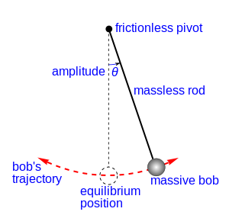

**Lenny’s Procedure:**

1. **Get supplies.**
2. **Change mass.**
3. **Measure time to swing.**
4. Look at the procedure above written by a physical science student for his science expo project. Determine the independent, dependent, and control variables he chose for his experiment.

Independent: ______________________ Dependent: _______________________

Controls: _________________________________________________________

1. Are the control variables controlled? Explain.________________________ ________________________________________________________________
2. Is there enough detail to replicate (repeat) the experiment? Explain. ________________________________________________________________ ________________________________________________________________
3. Is this a good procedure? Why or why not? ________________________

**Sasha’s Procedure:**

**Supplies: nylon string, 20 – USS flat washers 5/16, timer, protractor**

1. **Tie a loop in a length of string that is 1 m long.**
2. **Secure string to a stable object so it has room to swing back and forth freely.**
3. **Open paper clip and hook to string loop.**
4. **Place two washers on the paperclip to serve as the bob (mass on the end of the string).**
5. **Pull the pendulum back to an angle of 20˚ from vertical and release.**
6. **Start timer when the pendulum swings back to its starting point.**
7. **Count 10 swings back and forth (out and back counts as one).**
8. **Stop timer at the end of the 10th swing.**
9. **Repeat the steps above adding two washers to the paperclip each time.**
10. Look at the procedure above written by a physical science student for her science expo project. Determine the independent, dependent, and control variables she chose for her experiment.

Independent: ___________________ Dependent: _______________________

Controls: ________________________________________________________

1. Are the control variables controlled? Explain. __________________________ ________________________________________________________________
2. Is there enough detail to replicate (repeat) the experiment? Explain. ________________________________________________________________ ________________________________________________________________
3. Is this a good procedure? Why or why not? ___________________________

**Tigo’s Procedure:**

**Supplies: nylon string, 500-g brass mass, timer, protractor**

1. **Tie a loop in a length of string that is 70 cm long.**
2. **Secure string to a stable object so it has room to swing back and forth freely.**
3. **Place 500-g mass on the end of the string.**
4. **Pull the pendulum back to an angle of 5˚ from vertical and release.**
5. **Start timer when the pendulum swings back to its starting point.**
6. **Count 10 swings back and forth (out and back counts as one).**
7. **Stop timer at the end of the 10th swing.**
8. **Increase string length by 10 cm.**
   1. **Repeat steps above increasing angle of release by 5˚ each time.**
9. Look at the procedure above written by a physical science student for his science expo project. Determine the independent, dependent, and control variables he chose for his experiment.

Independent: ____________________ Dependent: _______________________

Controls: _________________________________________________________

1. Are the control variables controlled? Explain. __________________________ ________________________________________________________________
2. Is there enough detail to replicate (repeat) the experiment? Explain. ________________________________________________________________________________________________________________________________
3. Is this a good procedure? Why or why not? ___________________________

C:\Documents and Settings\MWiedenfeld\Local Settings\Temporary Internet Files\Content.IE5\34HD219W\MC900411244[1].wmf Call your instructor over to check off learning target.

**NOW FILL THE FACTS YOU LEARNED INTO YOUR ESSENTIAL FACTS BOOKLET FOR UNIT 1!**