Biome DBQ

Biomes – Temperature and Precipitation

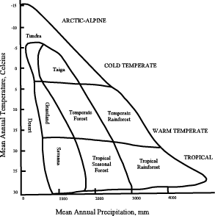

Explain the diagram above by answering the following questions:
- How does temperature and precipitation influence biomes?
- How do global wind patterns determine where certain biomes occur?
- Do biomes tend to occur at the same latitudes? Explain.
- Can you have the same biomes at different latitudes? Explain.

Conversion of Biomes to Human Use

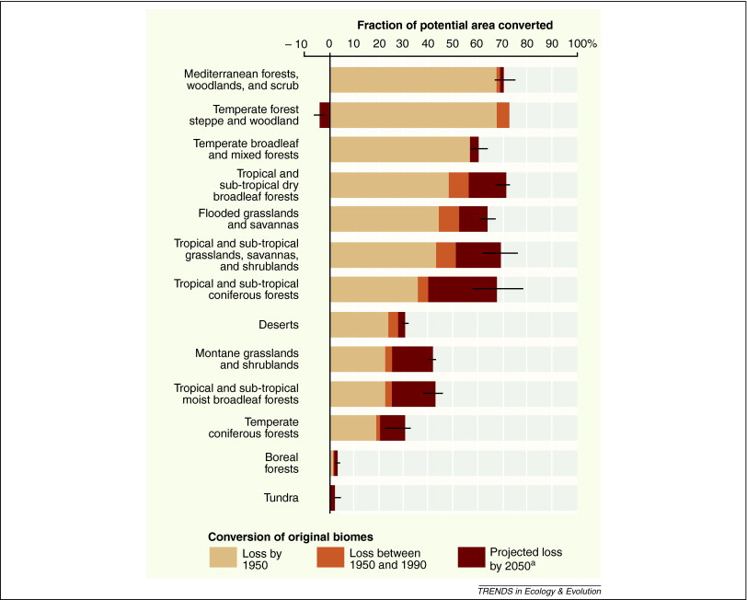

Explain the diagram above by answering the following questions:
- Which biome is in the most danger in terms of total loss?
- Which biome is projected to lose the most area by 2050?
- What factors are causing biomes area to be lost?
- What could be done to prevent further loss?

